**# It prints the first 5 items in the table**

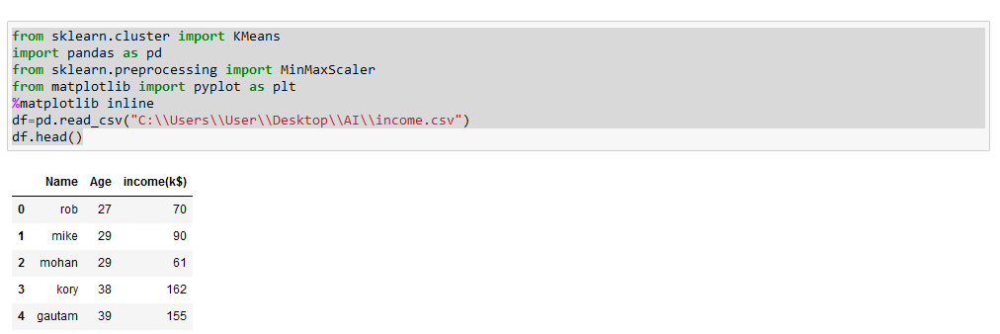

**Scatter Plot and Predict with KM**

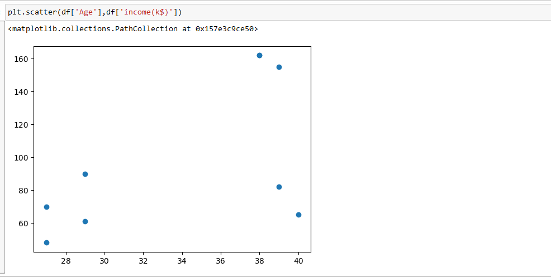

**# Here you will get a scatter plot and you can see roughly the number of clusters**

**# You just accept the default parameters and proceed to the next step**

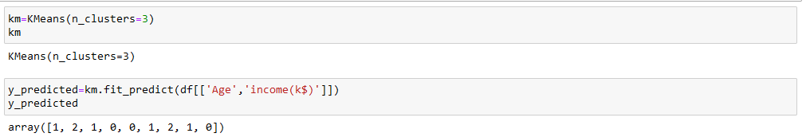

**# You get an array. The clusters are labelled 0, 1, and 2**

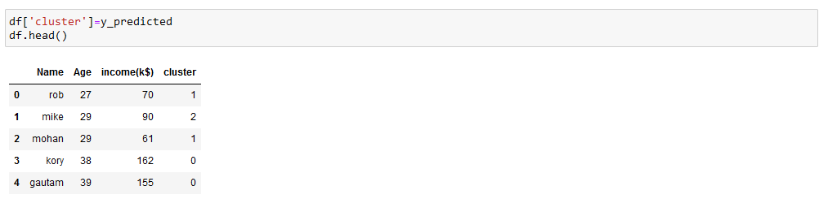

**Visualizing the Clusters**

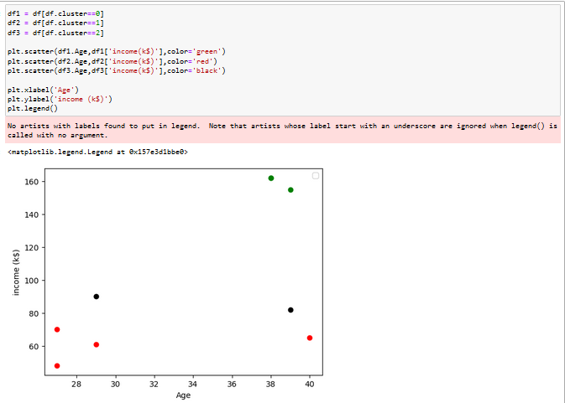

**using the min-max scaler**

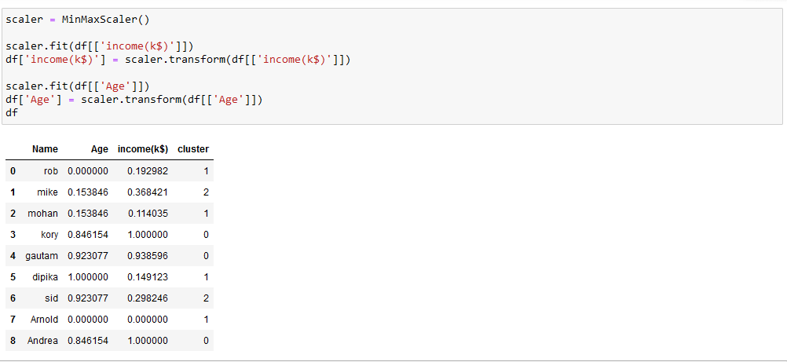

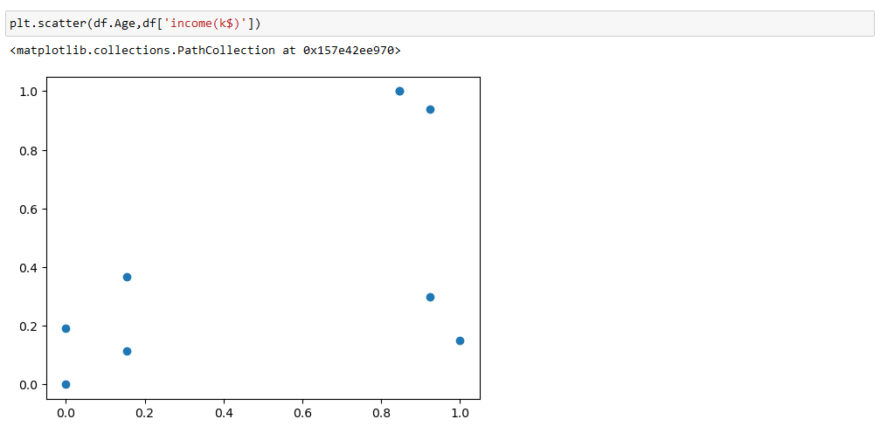

#plotting the plot using minmaxscaler ()

**#viewing the arrays**

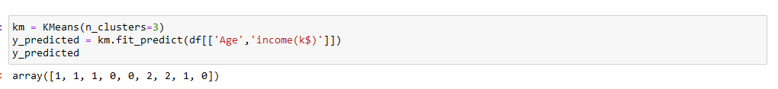

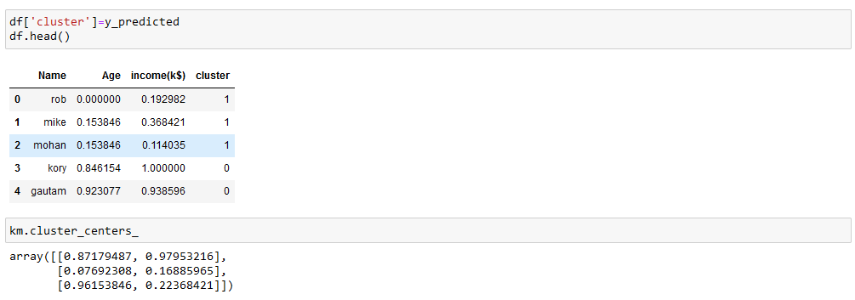

**#final cluster using minmax**

